**Curriculum Vitae**

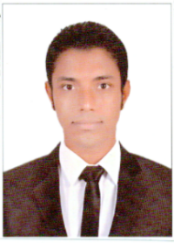

**--Personal Details:**

**-Name: Reda Hamed Mahmoud Salem Khedr.**

**-Nationality: Egyptian.**

**-Date of Birth: 11-03-1990.**

**-Age: 32.**

**-Military service: Final Exemption.**

**-Marital Status: Single.**

**-Current Profession: customer service and sales in El kenany Group.**

**-Mobile number and Whatsapp: 00201090144928**

**-Address: El Mansoura City – Dakahlia Governorate.**

**--Education:**

**-Graduated from Delta Academy for Science-Delta higher institute for computer.**

**-Bachelor of Management Information Systems 2011 - English Department - Graduated with Grade Excellent.**

**-ICDL Certificate.**

**-Diploma in Marketing from Mansoura University.**

**-Certificate in English from Mansoura University.**

**-TOEFL IBT Certificate.**

**-Self-study English Courses from the internet.**

**-Courses in Accounting.**

**--Work and Experiences:**

**-work as English instructor in ICTC Centre from 2012 to 2014.**

**-work as technical support at WE Egypt Telecom from 2015 to 2017.**

**-work as Sales online at WE Egypt Telecom from 2018 to 2019.**

**-work as Customer Service at WE Telecom Egypt from 2020 to 2022.**